Who is lynda powell?  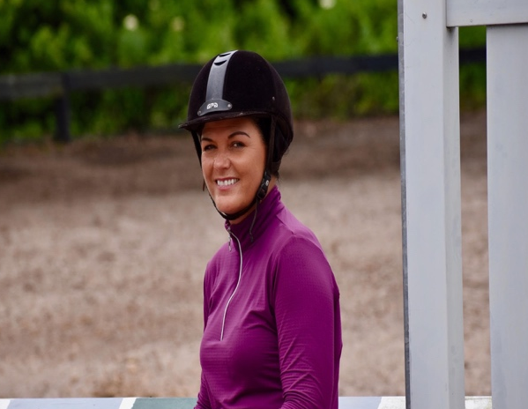  Lynda Powell has been running the Keilyn Lesson Program in the Tampa area since 1986. As a founding partner of Keilyn, she brings to the students over 45 years’ experience teaching, training, riding, and showing. She is dedicated to passing on her vast knowledge and expertise to passionate young equestrians, guiding them towards their riding goals in a professional setting. |  | Address  17508 Marsh Road, Lutz, FL 33558  contact us  Keilyn Incorporated | (813) 714-0493 | keilynincorporated@gmail.com  www.keilynincorporated.com  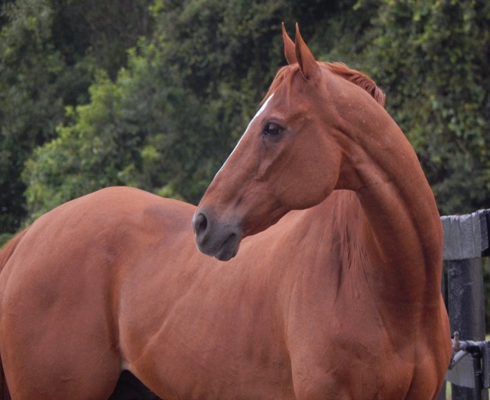 |  | 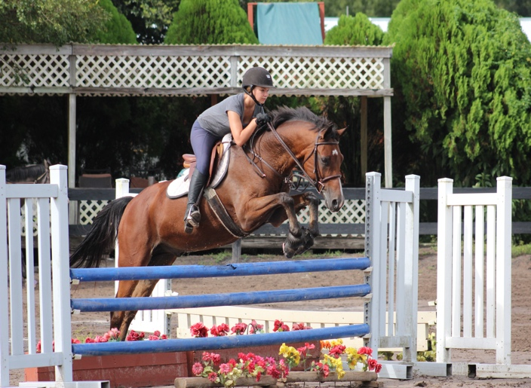  Keilyn Riding Lesson Program

What is the Keilyn Riding Lesson Program?  - The Keilyn lesson program offers professional, comprehensive instruction for beginner and experienced riders in hunt seat equitation, hunter, and jumper riding.  - A fixture in the Tampa Bay area for over 30 years, we have built our reputation by providing our students quality instruction on well-schooled horses in top condition.  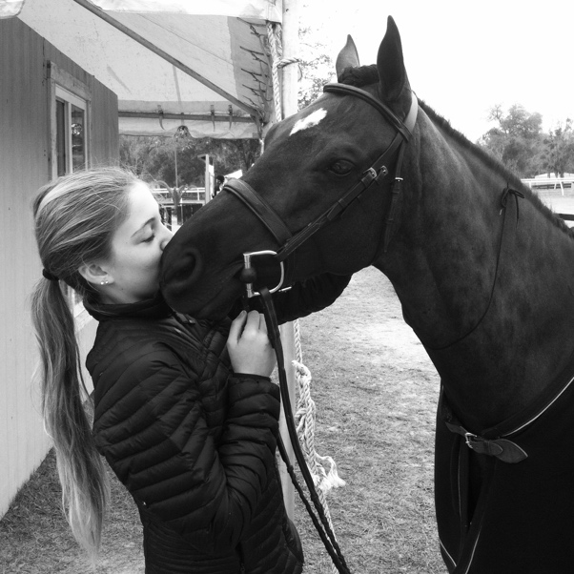  - Correct and safe horsemanship while mounted and unmounted are stressed, with riders being supervised at all times by adult instructors and staff. |  | What is involved in a lesson?  New students are scheduled for an evaluation to start. The evaluation consists of a 30-minute private lesson which gives the instructor a chance to build a one-on-one relationship with the student. After that, riders may continue in 30-minute private lessons or, at the instructor’s discretion, may be offered a 60-minute group class with riders at the same level of ability.  Lesson levels are as follows:  - Walk-trot and walk-trot-canter classes consist of training at the walk, sitting trot, posting trot, and canter. Safety, position, and horsemanship are stressed.  - Beginner jumping consists of advancing flat work from the previous level, as well as the basics of jumping 12-18”.  - Intermediate jumping continues the flat education and students will progress to jumping 18” to 2’3”.  - Advanced jumping is for the student who is proficient on the flat with and without stirrups, has a secure position over fences, and will include jumping up to 2’6”. |  | Pricing and Further Information  - In addition to lessons, our program also includes opportunities to participate in schooling shows at home, as well as winter and summer break stable management programs—weekly sessions that give riders a more in-depth, hands-on educational experience.  - All lessons are $60.00 each. Payment must be made in full by cash or check the day the lesson is taken (If a student fails to make a payment for any reason on the day the lesson is taken, there will be a $30.00 late charge for that lesson).  