Who is lynda powell?  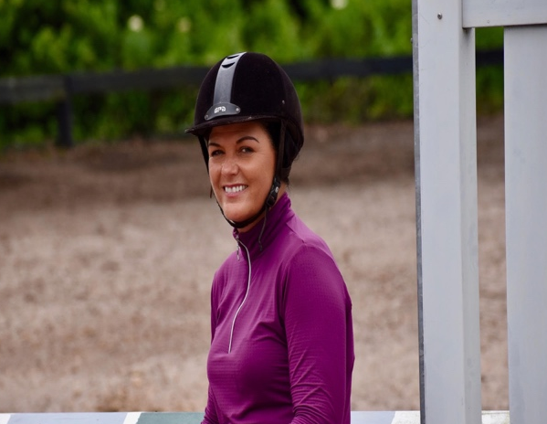  Lynda Powell has been running the K.S.R.P. in the Tampa area since 1986. As a founding partner of Keilyn, she brings to the students over 45 years’ experience teaching, training, riding, and showing. She is dedicated to passing on her vast knowledge and expertise to passionate young equestrians, guiding them towards their riding goals in a professional setting. |  | Address  17508 Marsh Road, Lutz, FL 33558  contact us  Keilyn Incorporated | (813) 714-0493 | keilynincorporated@gmail.com  www.keilynincorporated.com |  | Keilyn Summer Riding Program  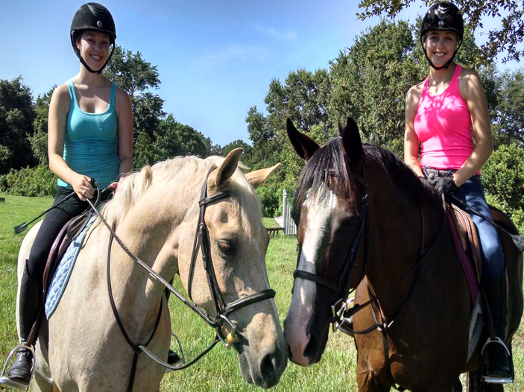  Not a Typical Summer Camp

What is the Keilyn Summer Riding Program?  - Not a typical “summer camp”, we do not offer crafts, games, or the like. Our program is built around our instructors’ credentials, offering our participants a unique learning experience.  - The Keilyn Summer Riding Program (K.S.R.P.) places emphasis on rider responsibility and proper horse care. Participants will be taught understanding and appreciation of our equine partners. Safety being paramount, students will be supervised at all times by well-trained staff. Well-schooled horses and ponies round out our team to educate riders at any level.  - The K.S.R.P. is open to students ages seven and up, beginner to advanced, and is designed for those interested in hunt seat (English) style riding which is a prerequisite for jumping lessons. |  | When is it and How Do I Sign Up?  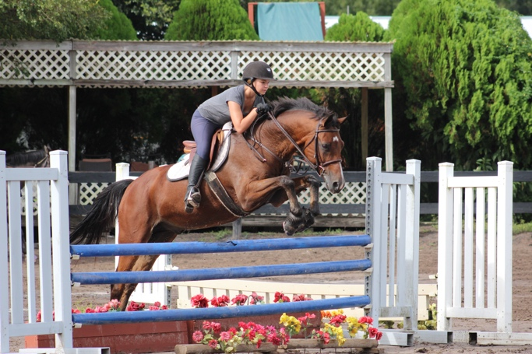  - Our program runs Monday through Friday 9 a.m. to 2 p.m.  - See our website for enrollment dates or contact Lynda Powell. |  | Pricing and Further Information  - Tuition is $500 per session.  - We ask that interested students be signed up at least two weeks before the start of a session  - We offer a 10% discount for multiple weeks and/or students from the same family.  - A non-refundable registration fee of $250 per student/per session is required to reserve the rider’s place. The registration fee will be applied to total tuition and balance must be paid at least one week prior to each session.  - For more information, program dates, and registration, call or text Lynda Powell at 813-714-0493.

